Day 6 JS Introduction

JS – Java Script

What is js? Pros & Cons

Variables (var, let, const)

Data types, operators

Conditionals, loops (for, while, for-of)

Functions (declaration, expression, arrow)

Arrays, Objects, Map, Set

String and Array methods

DOM manipulation (querySelector, events, innerHTML)

Event handling (click, input, etc.)

AJAX

What is JS – Is a Loosely typed, multi paradigm, object based scripting lang.
Loosely typed/Weakly typed (Dynamically typed) – Variables type will be assigned automatically.
Multi-Paradigm – Functional programming, Object based, event driven, Single threaded.

Earlier days, JS was created as supporting lang for web pages. (It works along with HTML, CSS)

Source Code (Human Readable format) Compiler Object Code (Machine Readable format)
Underlying hardware.
JSRE – JavaScript Run Time Environment. (It’s a Environment to run JS Code)

JS get’s all it’s specification from ECMA -Script.

Unlike JAVA, JS is a interpreted lang. (Reads and converts line by line)

JS was running inside the browser only during it’s initial days. It was running with the help of JS Engine which is embedded inside the browser.

Source Code Compiler Byte Code (intermediate code)
JVM – Java Virtual Machine. (It’s a Machine which is created only by the software)

Scripting Lang
Server Side Lang.

JS Code – DOM Manipulation, Error Handling, Adding Interactivity.
DOM – Document Object Model – Tree based representation of the Currently loaded HTML.
DOM will created and Managed by Web-Browser.
Client Side Validation - email validation – [a-z], [A-Z] [0-9] @ . (correct format or not)
Server Side Validation – Already registered customer or not.

Different ways of Adding JS to the Web Page

- Inline (Event Handlers)
- Internal <script> </script>
- External External JS file (Recommended)

- Stand Alone Application (Desktop Application) [Download & Install]
- Web Application (It’s accessed inside browser only – Internet connection is compulsory)
- Enterprise Application

MS-Office ( 0-365)

AJAX – Asynchronous JS & XML

Http – Request & Response (HttpRequest & HttpResponse)
- Http is a stateless protocol.
- Http is a synchronous communication (Blocking communication)

XMLHttpRequest – 1) Partial Page reload 2) send data in background.
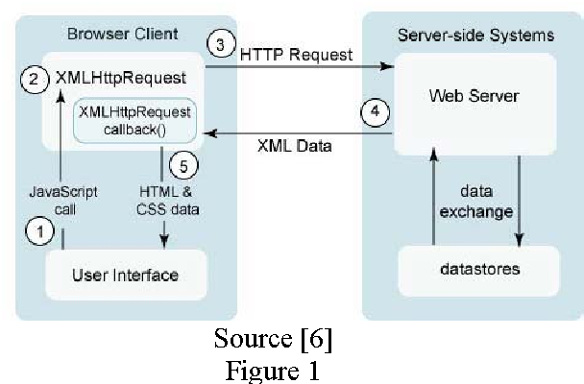
Blocking Mode (Synch Operation)

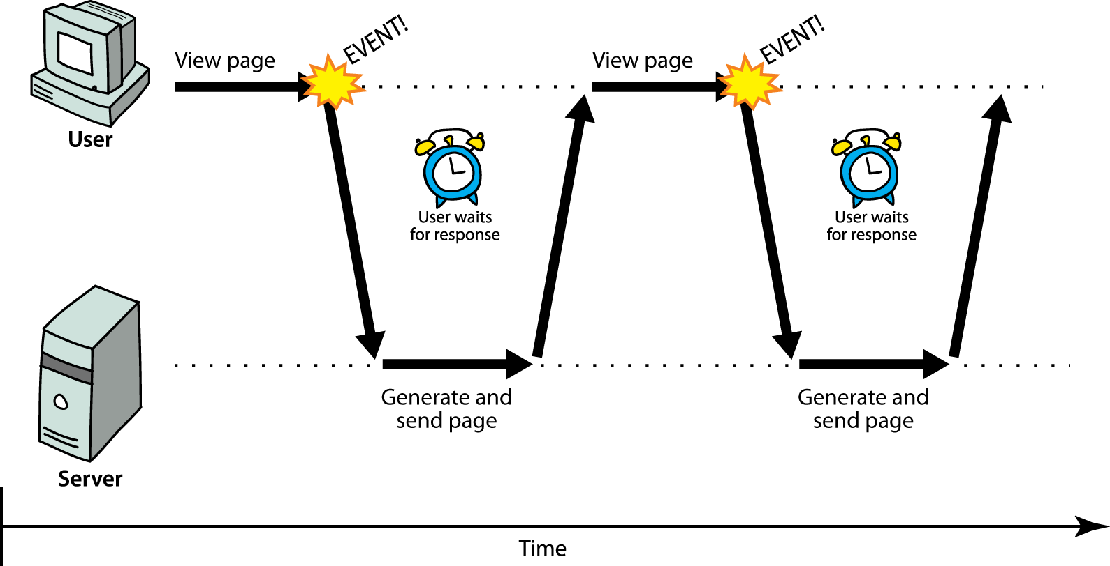

Non-Blocking Mode (Async Operation)

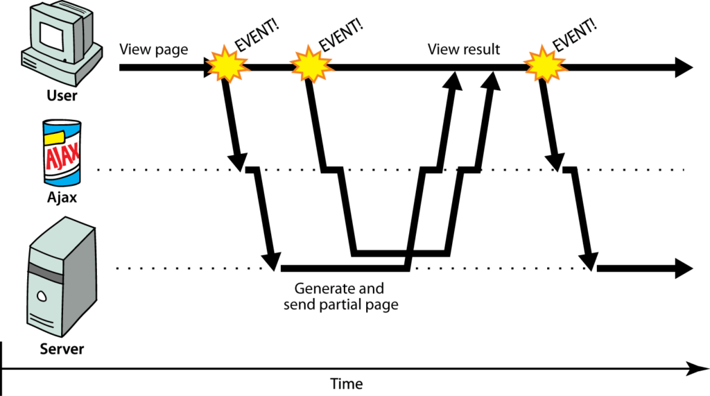

Functions type in JS
- Normal function or Named Function
- Arrow Function (Anonymous Function)
- IIFE (Immediately Invoked Function Expression)
- Call-back Function (function passed as an argument)
- Functional Expression (Functions assigned to a variable)
- Recursive Functions (Function call on it’s own)

HTML, CSS & JS = Static Contents.
Server Side Coding – Java/Python/ASP/JSP/PHP (Web Server) [Tomcat, Nginx, IIS, WAMP, ZAMP etc.,]

Objective, Key Actors, and Core Modules required for the HRD (High-Level Requirement Document

1. HRD Structure Overview
A standard HRD should include the following sections for any of the projects below:
- Project Scope: What is included and excluded.
- User Personas: Who uses the system.
- Functional Requirements: The features (Modules).
- Non-Functional Requirements: Security, Performance, Scalability.
- Technology Stack: Proposed tools.

Group A: Enterprise Management Systems
1. Employee Attendance Management System
Objective: To automate the tracking of employee working hours, minimizing manual errors and integrating with payroll.
- Actors: Employee, HR Admin, Reporting Manager.
Module | Key Features
Authentication | Biometric integration, RFID card, or Geo-fencing mobile login.
Shift Management | Define shift timings, roster creation, and rotation logic.
Leave Management | Apply for leave, approval workflows, leave balance calculation.
Reporting | Late-in/Early-out reports, overtime calculation, monthly attendance summary for payroll.
2. Training Management System (Corporate LMS)
Objective: To manage employee skill development, course delivery, and training effectiveness tracking.
- Actors: Trainee (Employee), Trainer, Training Manager.
Module | Key Features
Course Catalog | Repository of videos, PDFs, and SCORM packages.
Enrollment | Self-enrollment or Manager-nominated assignment.
Assessment | Quizzes, coding tests, or subjective feedback forms.
Certification | Auto-generation of certificates upon course completion.
3. Visitors Management System
Objective: To secure physical premises by tracking guest entry/exit and eliminating paper logbooks.
- Actors: Security Guard, Receptionist, Host (Employee), Visitor.
Module | Key Features
Pre-Registration | Host sends a QR code invite to the visitor via email/SMS.
Check-In Kiosk | Visitor scans QR code or enters details; photo capture; badge printing.
Notifications | Host receives real-time alert (SMS/Push) when visitor arrives.
Audit Logs | Historical data of who visited whom and duration of stay.

Group B: Consumer Service Applications
4. Online Food Ordering System
Objective: To connect hungry customers with restaurants via a web/mobile platform for delivery or pickup.
- Actors: Customer, Restaurant Partner, Delivery Agent, System Admin.
Module | Key Features
Discovery | Search by cuisine, location, rating; View Menus.
Cart & Order | Customize items (toppings), Apply coupons, Checkout.
Order Tracking | Real-time status (Preparing, Picked Up, On the way) with map view.
Partner App | Restaurants manage menu/inventory; Drivers receive delivery tasks.
5. Digital Library Management
Objective: To manage the cataloging, borrowing, and reading of digital assets (eBooks, Journals).
- Actors: Member, Librarian, Admin.
Module | Key Features
Catalog Management | ISBN indexing, categorization (Genre, Author), DRM protection.
Circulation | Check-out (download/view), auto-return (expiry), hold/reservation requests.
Membership | Subscription plans, fine management (for late physical returns if hybrid).
Reader Interface | Built-in PDF/ePub reader with bookmark and highlight capabilities.
6. Online Shopping Site (E-Commerce)
Objective: A B2C platform for selling goods with inventory management and secure payments.
- Actors: Shopper, Seller/Vendor, Admin, Support Agent.
Module | Key Features
Product Management | Inventory tracking, SKU management, variant handling (size/color).
Shopping Experience | Wishlist, Cart, Recommendations engine ("Customers who bought this...").
Checkout & Payment | Payment Gateway integration (Credit Card, UPI, Wallets), Tax calculation.
Order Fulfillment | Shipping integration, return/refund processing, invoice generation.

III. Common Non-Functional Requirements (NFRs)
For all the above projects, your HRD must state:
- Scalability: The system must handle X concurrent users (e.g., the Food Ordering app needs high concurrency during lunch hours).
- Security: Data encryption (SSL), GDPR/Data privacy compliance, and Role-Based Access Control (RBAC).
- Availability: 99.9% Uptime target.

